Physics Calculator

Leo Brown

University of Missouri – Kansas City

Table of Contents
Vision Statement 3
Requirements 4
Product Backlog 5
Sprint #1 6
Review 6
Retrospective 6
Sprint #2 7
Review 7
Retrospective 7
Sprint #3 8
Review 8
Retrospective 8
Sprint #4 9
Review 9
Retrospective 9
Sprint #5 10
Review 10
Retrospective 10
Sprint #6 11
Review 11
Retrospective 11

Vision Statement

This is where you put the vision for what your program will do. It should summarize key features, explain why this will be useful, and discuss what’s planned for immediate release and what’s envisioned for future development (stretch goals).

The Physics Calculator is a lightweight app used for organizing and calculating common formulas used within a math intensive discipline. Users will be able to enter in the formulas they would like to save, which can be categorized by subject and searched by keywords and tags. Numbers can be typed in for variables and the answer will be calculated by the app. This tool is useful for anyone who uses many different equations with varying degrees of frequency in a math-centered hobby or profession. Rather than having to memorize every equation that might be relevant to a project, or having to search the internet repeatedly to find a specific equation, the app will store these formulas for future use. The mobility and simplicity of the app means that more individuals can be mathematically fluent and prepared in a variety of situations without having to know any computational, scientific, or general purpose programming languages. The nature of the app also encourages learning and a deeper understanding of the terms behind the numbers.

Requirements
A discussion of what your application is required to have in functionality. It should identify user roles and goals/actions, and what the key features of the app should be.
Actor | Goal
Hobbyist engineer | Save and quickly access many different, equivalent versions of a formula, easy copy and paste for a sequence of equations
Highschool/ College student | Organize formulas by chapter/subject, create detailed explanation of formulas for better intrinsic understanding
Entrepreneur
Construction | Instantaneous changing of parameters, quick unit conversion (metric to US)
Part-time technician

Product Backlog
This will be updated throughout the semester as new PBIs are added, larger items are broken into smaller ones, and completed items removed.

Story ID | Story | Story Points  (in est. hours) | Priority | Status
1 | As a student, I want to search saved formulas so I can easily find the correct formula for a problem. | 15 | 2
2 | As a student, I want to have a wiki entry for every formula so its application and relation to other formulas is clear. | 18 | 3
3 | As a hobbyist, I want to save custom formulas so that I can save time on project specific calculations. | 40 | 1 | In Progress
4 | As someone in construction, I want to use sliders to alter variable values so I can make quick estimations. | 20 | 4

Sprint #1

Sprint Backlog
Story ID | Story / Task | Estimated  Hours | Actual  Hours

Review

[Screenshots, etc go here. This is where you discuss the product, describing what was done this sprint (potentially shippable product increment) and what was planned for the sprint but was not done. ]

Retrospective
[This is where you discuss the process. What went well (and are you planning to do more of that?) What didn’t go so well (and do you have a way to do less of that)? What changes are you planning to make in how you plan & carry out the next sprint?]

Sprint #2

Sprint Backlog
Story ID | Story / Task | Estimated  Hours | Actual  Hours
3 | Create functional equation and factor classes | 4 | 4
 | Create mock calculation screen with editable fields | 3 | 8
 | Preliminary Kotlin research | 4 | 5

Story points completed: 11
Sprints completed: 2
Velocity: 11/2 : 5.5 points/sprint.

Review

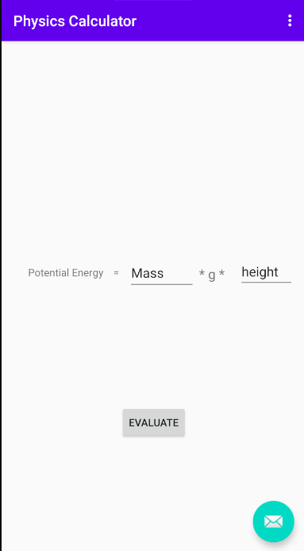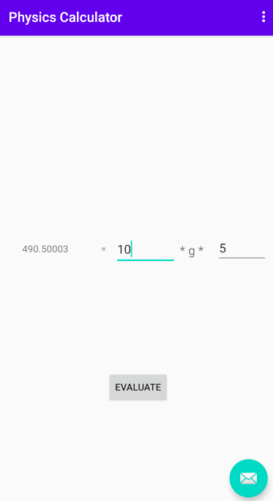

For this sprint, the factor and equation classes were written and established with limited functionality. Minimal testing was done to catch obvious errors, but full unit tests were not written. An interactable mock-up of the equation screen was also created, but efforts to vary the number of input fields based on the factors in the equation were not realized by the end of the sprint.

Retrospective
I started the sprint off on a bad food, having already not done the first sprint, and did not create effective schedules and hour estimations as a result. The Kotlin language is fairly developer friendly, and my estimate for creating the fundamental classes was not far off. However, integrating those classes with the android UI proved much more difficult than I imagined. I had originally planned to create a prototype with a small but variable number of input fields, but was vastly underprepared, and spent a lot of time on a feature that would not be finished and could not be included by the sprint end. I also did not set aside enough time for unit testing. I plan to put a lot more time into UI research, testing, and more granular tasks during my next sprint. This may mean I do not progress in the development and features as fast as I would have hoped, but I will be creating a more solid foundation that I can confidently build upon. Hopefully this, along with a large amount of additional time committed to make up for missing iteration 1, will result in a dramatic increase in velocity for the next sprint.

Sprint #3

Sprint Backlog
Story ID | Story / Task | Estimated  Hours | Actual  Hours

Review

[Screenshots, etc go here. This is where you discuss the product, describing what was done this sprint (potentially shippable product increment) and what was planned for the sprint but was not done. ]

Retrospective
[This is where you discuss the process. What went well (and are you planning to do more of that?) What didn’t go so well (and do you have a way to do less of that)? What changes are you planning to make in how you plan & carry out the next sprint?]

Sprint #4

Sprint Backlog
Story ID | Story / Task | Estimated  Hours | Actual  Hours

Review

[Screenshots, etc go here. This is where you discuss the product, describing what was done this sprint (potentially shippable product increment) and what was planned for the sprint but was not done. ]

Retrospective
[This is where you discuss the process. What went well (and are you planning to do more of that?) What didn’t go so well (and do you have a way to do less of that)? What changes are you planning to make in how you plan & carry out the next sprint?]

Sprint #5

Sprint Backlog
Story ID | Story / Task | Estimated  Hours | Actual  Hours

Review

[Screenshots, etc go here. This is where you discuss the product, describing what was done this sprint (potentially shippable product increment) and what was planned for the sprint but was not done. ]

Retrospective
[This is where you discuss the process. What went well (and are you planning to do more of that?) What didn’t go so well (and do you have a way to do less of that)? What changes are you planning to make in how you plan & carry out the next sprint?]

Sprint #6

Sprint Backlog
Story ID | Story / Task | Estimated  Hours | Actual  Hours

Review

[Screenshots, etc go here. This is where you discuss the product, describing what was done this sprint (potentially shippable product increment) and what was planned for the sprint but was not done. ]

Retrospective
[This is where you discuss the process. What went well (and are you planning to do more of that?) What didn’t go so well (and do you have a way to do less of that)? What changes are you planning to make in how you plan & carry out the next sprint?]

